 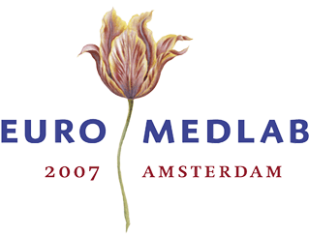Highlights of history

Invitation

On the occasion of the 17th IFCC-FESCC EuroMedLab Congress and the 60th Anniversary of the Netherlands Society for Clinical Chemistry and laboratory medicine (NVKC), the Historical Committee of the NVKC cordially invites you to our symposium and exhibition on the history of Clinical Chemistry

Exhibition

The exhibition opens Monday 4 June at 14.00 hr and is situated at the RAI Convention Centre, first floor next to the Auditorium. Historical instruments, books and photographs are displayed together with posters summarizing the major landmarks. We will gladly answer your questions about the materials exposed.

Symposium

Wednesday 6 June, 14.00 – 16.00 hr RAI Convention Centre Room E/F

Chair: dr. B.G. Blijenberg / drs J.J. Heeren

Speakers

Prof. dr. H. Beukers, Leyden University
“A iatrochemist’s view on health and disease”

dr J.G. Lines, England
“The exponential growth of clinical chemistry. Our heritage”

Prof. dr. J.H.H. Thijssen, Utrecht University
“A century of hormones: from conductors to players in an orchestra”

