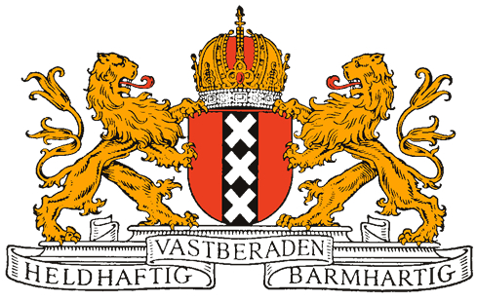
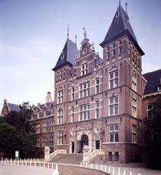

First European Congress on Clinical Chemistry
Amsterdam, September 23 – 28, 1954
Under the patronage of
H.E. the Minister of Education, Arts and Sciences
H.E. the Minister of Social Affairs
The Burgomaster of Amsterdam
Under the auspices of the “Commission on Clinical Chemistry” of the International Union of Pure and Applied Chemistry and organized by the Netherlands Society for Clinical Chemistry

General information

1. All sessions of the Congress will take place in the “Koninklijk Instituut voor de Tropen” (Royal Institute for the Tropics) in Amsterdam
2. The official languages of the Congress are English, French and German
3. The Congress-fee has been fixed at Dfl. 25 ( ± € 12) per full member; for associate members (wives and other relatives) the fee will be Dfl. 10 ( ± € 4)

Exhibition

During the Congress an exhibition of instruments pertaining to the subjects of the Congress will be held on the first floor of the Royal Institute for the Tropics
Only instruments made in the Netherlands will be shown:
1. Nederlandse Optiek- en Instrumentenfabriek Dr. C.E. Bleeker N.V. Zeist
2. N.V. Instrumentenfabriek en –handel P.J Kipp en Zonen, Delft
3. Technisch Handelsbureau J.J. van Oortmerssen, The Hague
4. N.V. Philips Gloeilampenfabriek, Eindhoven

Scientific scope

The Congress will be divided into two symposia of two days each. The subjects of these symposia will be:
1. Isotopes in the clinico-chemical laboratory
2. The physical methods of measurement in connection with clinico-chemical problems
These subjects have been chosen in view of the increasing importance of the use of isotopes and the application of physical methods in clinical chemistry

Participation

A total number of 351 participants and partners has been registered, coming from:
Argentina (1), Belgium (15), Bolivia (1), Canada (1), Denmark (17), Egypt (1), Finland (3), France (40), Germany (33), Great Britain (54), Greece (1), India (3), Israel (3), Italy (7), Netherlands (99), Norway (2), Spain (8), Sweden (24), Switzerland (13), Turkey (7), USA (4), Yugoslavia (14).

Photograph

The official photograph of the Congress will be made on Thursday 23rd at noon, in front of the Royal Institute for the Tropics. Copies can be ordered at the Reception Office.

