 Highlights of history: development of immunochemistry
JJ Heeren, Breda and JPM Wielders, Amersfoort
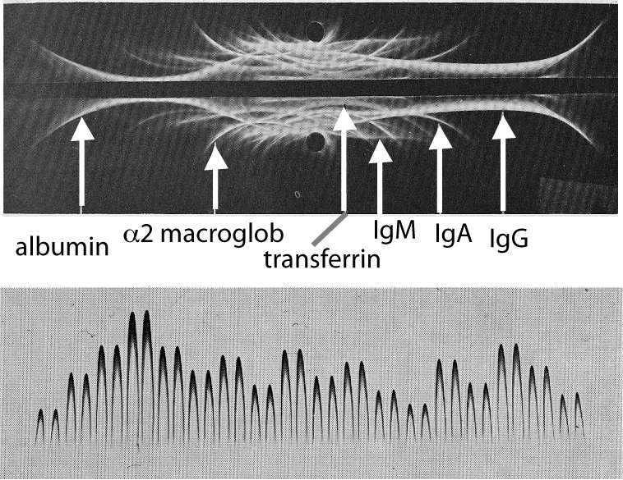

Immunology – and therefore immunochemistry - is may be one of the oldest branches of medicine; the essence of it was already described by the Greek Thucydides in the 5th century B.C. The scientific approach may be dated from 1798 with the publication of ‘Inquiry into the Cause of Variolae Vaccinae’ by the English physician Edward Jenner (1749-1823). It was the German scientist Paul Ehrlich (1854-1915) who postulated the chemical basis of the immunologic response. The name immunochemistry’ itself was introduced in 1904 by Ehrlich’s contemporary Svante Arrhenius (1859-1927).

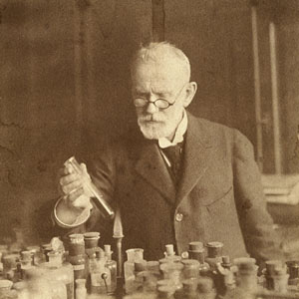
Fig 1 Paul Ehrlich
Nobelprize winner 1908

Immunochemistry is based on the antigen-antibody reaction and in the course of time many techniques are developed to quantify proteins using that reaction, especially after the Heidelberger-Kendall research in the thirties of the 20th century. But the real and rather stormy development came only after the introduction of the radioimmunochemical assay for insulin in serum by Solomon. Berson and Rosalyn Yalow in 1960.

From cowpox to immunodiffusion
Jenner, a country-doctor, was impressed by rumors that milkmaids who had been exposed to cowpox, were immune to smallpox. He started a number of experiments of immunization by inoculation. Later the French chemist Louis Pasteur (1823-1895) introduced the term vaccination and used the method in preparing the rabies vaccin.
It took some time before theory and practice of mmunochemistry found their way to the medical laboratory. In 1926 it was shown that antibodies had a protein character; about ten years later Tiselius demonstrated with his famous experiments on electrophoresis these antibodies appear in the gamma-globulin fraction of serum.
The first immunochemical technique that found widespread application in hospital laboratories was the double diffusion method, about 1948 introduced by O. Ouchterlony.
It was a sensitive qualitative method, well known to everybody. Around 1965 G. Mancini et al developed a quantitative variant, the radial immunodiffusion method (RID). Mancini’s method made a commercially available version possible and quite a number of companies came with RID-plates on the market, with Behring setting the standard.

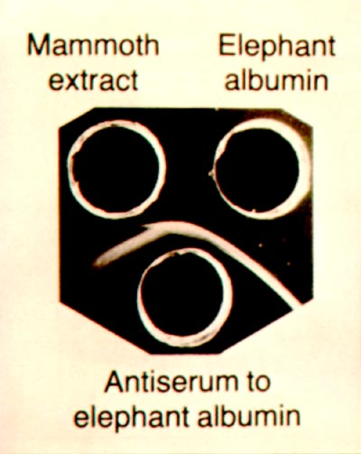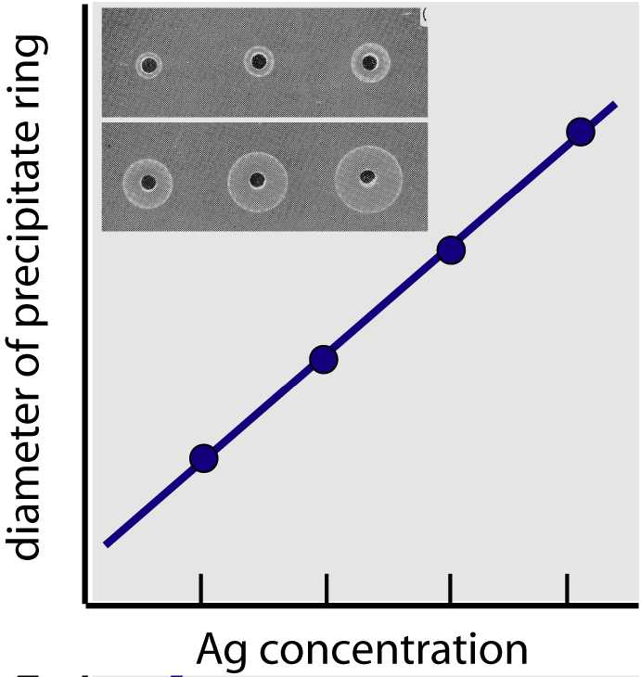

Fig 2a Ouchterlony pattern Fig 2b Mancini-calibration line

Immunoelectrophoresis
In 1953 the French scientist P. Grabar (1898 - 1986 ) and his colleague C.A. Williams developed a method in which the electrophoretic and immunochemical properties of the different kinds of antibodies were combined. Their immunoelectrophoretic method conquered in a relatively short period a position of its own in the clinical chemical laboratory, due to its possibility to make visible the characteristic changes that appear in the electrophoretic pattern that occur in diseases.

Figure 3: Immuno-electrophoretic pattern as seen with ‘Grabar & Williams’.

Immunodiffusion and immunoelectrophoresis appeared to be an ideal breeding ground for the development of quite a number of immunochemical techniques. Carl-Bertil Laurell (1919-2001), well known in protein electrophoresis, o.a. he discovered α1-antitrypsine deficiency, introduced the electro-immuno assay around 1966 (“rocket-electrophoresis”) for quantitative protein analysis. Later he combined it in a two-dimensional technique with usual agar electrophoresis to form crossed-immunoelectrophoresis or “tandem-cross” electrophoresis.
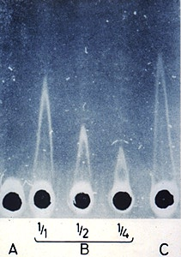

Fig 4 Dr C-B Laurell:
Rocket electrophoresis

In 1969 CA Alper patented immunofixation, a method still in use for detection of monoclonals in myeloma.
The quantitative determination of proteins by immunodiffusion and immunoelectrophoresis was replaced by turbidimetry and nephelometry in the last decades of the 20th century, made possible y the use of monoclonal antibody that became commercially available.

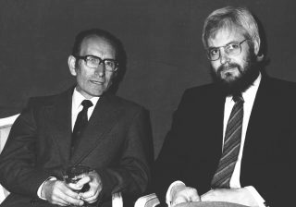
Georges JF Köhler (1946-1995) and César Milstein (1927-2002) published in 1975 a method for the production of monoclonal antibodies (Paul Ehrlich’s “magic bullet”). Monoclonals are produced by hybridomas: cells that are the result of fusion of selected B-cells from spleen or lymphe node with myeloma tumour cells. Monoclonals are used in quantitative analytical method but also as cancer-specific antigens for in-vivo medical treatment

Fig 5
Milstein (left) and Köhler

Radio- and enzyme immunoassay
The impressive development of quantitative immunochemistry in the medical laboratories began with the introduction of the radioimmunoassay (RIA) in the seventies. Due to its necessary safety precautions, regulations and permissions the new RIA laboratory set special demands on construction and staffing and soon became a special department within the lab. This completely new and very sensitive technique boosted our knowledge of endocrinology and gave birth to a new specialisation in clinical chemistry.
Very special calculations had to be made to process the data by the first generation of computers in the early seventies and especially David Rodbard should be mentioned in this aspect. About 20 years those laboratories were under the spell of their isotope laboratory. During the eighties – with the introduction of other labels like enzymes or fluorescent probes – the RIA’s and their special laboratories were gradually abandoned.

