 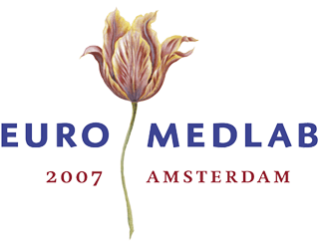Highlights of history: development of dry chemistry methods
JJ Heeren, Breda

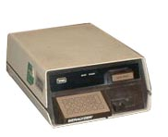
At the time the Netherlands Society for Clinical Chemistry was founded, hospital laboratories were still dominated by so called ‘wet chemistry’: the interiors of the labs showed an impressive mass of glas tubes, erlenmeyers, beakers and bottles, filled with different kinds of liquids. Sometimes the chemical name was placed on the bottles, sometimes curious names as Schlezinger, Fehling A, Fehling B were put on it.
The qualitative as well as the quantitative analyses demanded certain amounts of solutions, simple solutions but also quite complex solutions. By all means it was the era of pipettes, burettes, measuring cylinders, calibrated glassware and so on.

Fig1
Typical medical laboratory(1950)

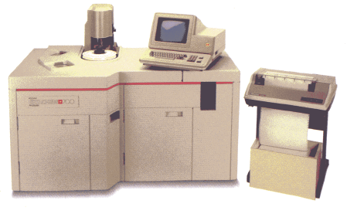
Probably one of the most frequently performed tests was the method, introduced by Hermann Fehling about 1850 to demonstrate the presence of sugar in urine and about 1900 modified by Stanley Benedict.
It was a wet method with potassium citrate, sodium carbonate and cupper sulphate as ingredients.
Since then and especially after the research of Banting & Best on insulin in the twenties of the last century it became clear that the availability of a simple and easy to perform glucose-test, favourably also available for the diabeticus himself, would be very important in controlling the disease.

During World War II the American scientists Compton and Treneer developed a tablet-test, based on the Benedict method. When the tablet was dissolved in a small amount of urine the colour of the solution appearing corresponded to the amount of sugar present. The tablet test, put on the market by Ames under the name Clinitest, was the first dry chemistry test.
Soon other tests became introduced, mostly also related to diabetes mellitus. Among them the keto-test, based on the reaction of Legal (about 1900) to demonstrate the presence of acetone.

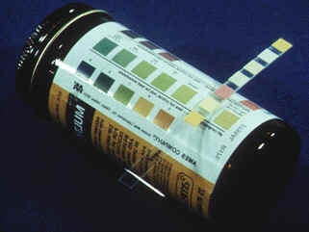
The introduction of the so called ‘dip-and-read’ strips speeded up another development. Fixation of different reagents in separated testpads on one strip brought together several tests in an elegant way. Semi-quantitative analysis became possible with the enclosure of a colour scale.

Fig 2: Dip-and-read strip

Of course there was the challenge to develop dry chemistry methods to estimate the amount of sugar and other constituents in blood.

Again it started with a glucose test, introduced in 1964 and based on the glucoseoxidase / peroxidase reaction. The development of dry chemistry methods for the use in blood meant the rise of reflectometry. Originally it wasn’t blood but serum that was used for this kind of dry chemistry methods. The Ames Seralyzer is an example of an apparatus, introduced about 1980, capable of measuring quite a number of metabolites and some drugs in serum
Fig 3 Seralyzer by reflection photometry.

A completely new method, introduced by Eastman Kodak at the 1978 IFCC International Congress in Mexico-City, appeared to be based on the multilayer “dry-slides” technology, during many years developed and improved by that photo-giant. Their Ektachem random access analyser initially could handle the amount 12 analytes, in later years that number increased to about 40. Advantage was the simplicity of loading and handling the reagent slides. During the years the limited flexibility of the concept and the huge costs of developing new tests for the multilayer technology became a significant drawback.

Fig 4 Kodak Ekatchem 700 Analyser

In an attempt to return to their core activities, Eastman Kodak sold their Ektachem analysers in 1995 to Johnson & Johnson. Nowadays they are on the market as Vitros chemistry systems.
The Ektachem analysers needed serum for its analyses. Boehringer Mannheim extended a line of development and introduced at the end of the eighties its Reflotron system. Now it is possible to use full blood as a sample; blood cells are separated from the plasma as a first step in the analytical process.

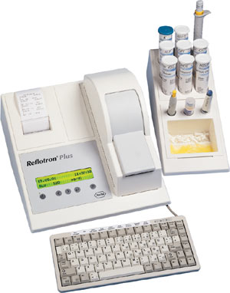
Fig 5 The Boehringer Reflotron system

Also Boehringer had to change its name; the company – founded in 1859 - was bought by La Roche.
The development of dry chemistry methods changed the practice of clinical chemistry and opened the way for home testing, near patient testing (POC) or desktop analyses for the general physician.

Dry chemistry brought the possibilities a clinical laboratory diagnosis outside the lab, which is partly a benefit but it can be hazardous as well. The performer of the “home medical test” bought at the chemists or ordered by internet may be unable to interpret the results and is not aware of the limitations of the method employed.

