 Highlights of history: quality control in the clinical laboratory
WE Elion – Gerritzen, Wassenaar

1900-1930 Hospital laboratories come into view
Only few hospitals have laboratory facilities. Textbooks at that time describe microbiology, microscopy and predominantly qualitative clinical chemistry tests. Faeces and gastric fluid are as popular as testing material, next to urine and blood. A Dutch textbook in 1924 describes only five quantitative tests.

1930-1940 From qualitative to quantitative testing
1931 Peters and Van Slyke publish their textbook “Quantitative Clinical Chemistry” and describe a number of 30 quantitative tests. Much attention is paid to the accuracy and preservation of Standard Solutions.
1931. WA Shewart, employee of Bell Telephone introduces the Statistical Process Control (SPC) chart to aid a manager in making scientific, efficient, economical decisions.

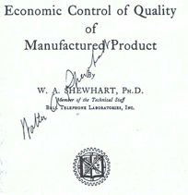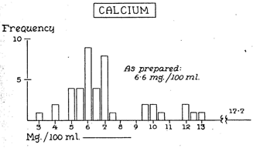
Shewart’s book 1931 Belk and Sunderman’s survey 1947

1940-1950 The first quality surveys
1947 Belk and Sundermann conduct the first “Survey of the accuracy of chemical analyses in clinical laboratories”. Aqueous solutions are distributed among 59 laboratories in Pennsylvania. Note the “target value” is designated as “weighed-in value.
1949 The first survey using aqueous solutions in the Netherlands is conducted by de Wael.

1950-1960 Registration of control results and target values
1950 Levy and Jennings adapt Shewarts SPC-charts to record control sample results performed in duplo: in one graph the mean is recorded, in the other the difference between the duplicate results is plotted.
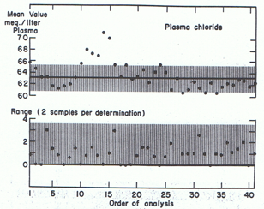
QC materials changed in time
- Aqueous standards ( second standard if test was read from curve)
-“Home-made” serum pools
- Commercial freeze dried sera, normal and pathological, assayed and unassayed, e.g.: Versatol and Versatol-A, Warner Chilcott, Monitrol (Dade), Precinorm, Precipath (Boehringer), Seronorm, Pathonorm,, Nyegaard
Ortho I , Ortho II, unassayed.
Levey-Jennings 1950 Early Dutch quality survey 1958

1951 The College of American Pathologists starts the manufacturing and distribution of Standard Solutions and urges its members to order and use them.
1953 The first International Survey is conducted by Wootton and King using freeze-dried horse serum undiluted and in a 70 % dilution.
1957 Holtz at the Dutch National Institute of Health (RIV) starts regular round-robins in the Netherlands using freeze-dried horse serum. Target values are determined by 3 reference laboratories.

Target values in surveys changed in time:
-“as prepared”, aqueous standard
-(average) result of reference laboratories
- mean of all laboratories (State of the Art!)
- mean of laboratories using the same method
- absolute value, e.g. by Isotope Dilution Mass Spectrometry

1960-1970 Youden plot and allowable limits of error
1963 Tonks reports on a survey of 170 Canadian laboratories, presenting the results of the 2 samples distributed in a bidimensional plot, allowing evaluation of accuracy and precision. Tonks proposes that analytical variability should be less than “1/4 of the normal range”.
1967 Campbell and Owen derive “acceptable reproducibility” from a clinicians
point of views.
1968 Barnett poposes Medical significant values: “ a synthesis of opinions by
clinicians and laboratory specialists”

1969. Skendzel and Youden present the two-sample “Youden-plot” designed to discriminate between random and systematic errors.

Youden-plot, design Scatter plot (Tonks 1963)

1970 Cotlove Harris and Williams argue that allowable limits should be based on intraindividual variability.
The discussion on Analytical Goals:
- “allowable limit of error should not exceed ¼ normal range” (Tonks 1963)
- Clinicians views (Campbell 1967, Barnett 1969, Elion 1982, Skendzel 1984)
- CV< ½ intraindividual variability (Harris 1970, Fraser et.al. 1988)
- CV <1/2 intraindividual variability or less than the” State of the Art” of the best 20 % of laboratories (Working group EGE Labs.1992)

1970-1980 Regional, national and international QC schemes are developed
Scandinavia: Eldjarn, Stromme, Groth, De Verdier, Dybkaer, Magid (NORDKEM)
Great Britain: Whitby, Whitehead
Germany: Von Boroviceny (INSTAND), Büttner, Stamm
France: Siest
Netherlands: Holtz, Jansen (SKZL)
Switzerland: Burgi, Zender
USA: Sundermann, Gilbert, Copeland
International QC-scheme: Wellcome

Different methods for quality management on the basis of control samples and patient samples are used: CUSUM, Deltachecking, Daily Mean

1973 Paul Cali publishes: ”An idea whose time has come” A system of Referee Methods, Applied Methods and Certified Standards Reference Materials are proposed. The discussion on “definitive”, “selected” and “bench” methods lasts ever since.

1980-1990 Westgard rules and analytical goals
1981 Westgard introduces the Westgard Multirule decision tree for daily control and these rules are incorporated in most QC-system in use.

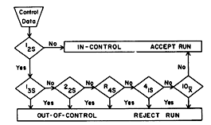

1985-present:
Focus on standardisation on methods: ECCLS, IFCC, NCCLS

1990-present
Total Quality Management and Accreditation of Medical Laboratories: eg ISO 15189

