 Highlights of history: the AutoAnalyzer era
Bert G Blijenberg en Jos PM Wielders

Historical background
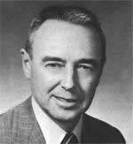
It is without doubt that for decades, i.e. from about 1960 to about 1980, the AutoAnalyzer has played a dominant role in the world of clinical chemistry. The story begins with an idea of Leonard Skeggs (1918 - 2002) being head of a Clinical Chemistry Laboratory at Case Western Reserve University (USA). Soon after his appointment in 1948, he began to look for a way to deal with the error-prone repititive steps in manual analysis caused by a continuously increasing demand. Working in his own basement at home he finally came up with a prototype in 1950 that was rejected by several companies.

Fig 1 Leonard T. Skeggs jr.
Erroneously, it was initially also rejected by the Technicon Corporation, a manufacturer of automatic tissue processors and owned by Edwin Weiskopf and later by his son Jack Whitehead. Later on, in 1953, negociations with Skeggs were re-opened by intervention of a Technicon salesman named Roesch. In the mean time Skeggs had made several improvements in his train of test tubes (his own words), resulting in the machine shown in figure 2.
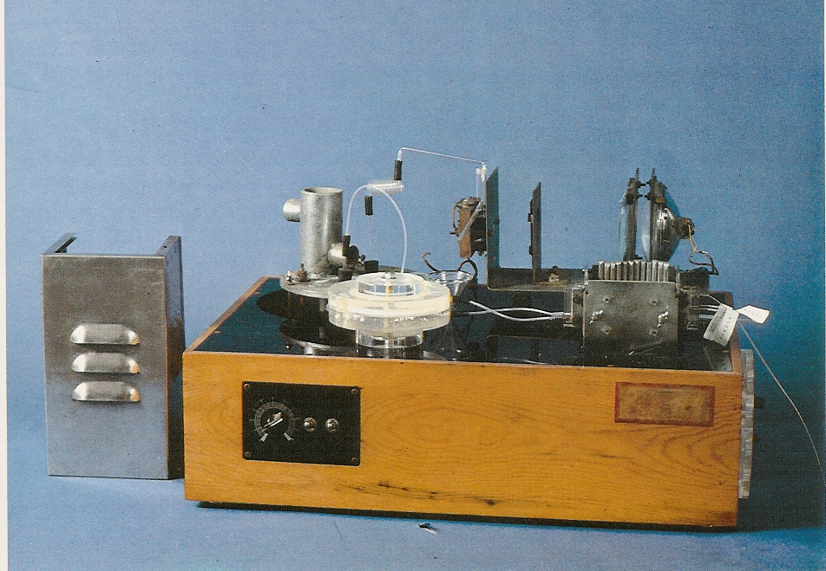
Fig 2 AutoAnalyzer prototype version 1953

This prototype demonstrated the validity of the idea and formed the basis for a license to patent the AutoAnalyzer. Without this patent protection, Technicon could never had afforded to pursue the expensive development of the machine.
In addition to the continuous flow of samples and reagents, there were three unique features of the machine

a) a dialyzing membrane to remove the proteins in the sample

b) tubing transporting the samples separated and segmented by air bubbles,

c) mixing coils in which samples and reagents were continuously mixed while being separated from other samples.

Heating or incubation in order to bring the reaction to the desired level of completion were performed during continuous passage through a lengthy glass coil. Photometric measurement was performed by monitoring transmitted light of a flow-through cuvette at a given wavelength. It took Technicon more than 3 years of engineering and fine-tuning before the first single-channel AutoAnalyzer was launched commercially in 1957 (fig 3).

A new marketing strategy was developed in order to promote a machine that was a true revolution in laboratory instrumentation. Technicon decided to market the AutoAnalyzer as a complete system – instrument, reagents, and instruction to its users (the first standardized customer training). In addition, it was decided to perform clinical evaluations (unusual at that time) and to promote the AutoAnalyzer at professional meetings and through scientific papers.

Later developments

The first 10 AutoAnalyzers were sold in the USA for $ 3200 each, an extremely high price. Nevertheless, Technicon soon had many orders to fill.

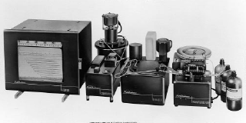

Fig 3 First commercial AutoAnalyzer launched in 1957

The analyzer proved to be an instant success. Technicon’s sales mounted and soon many laboratories in the USA and abroad had one or more AutoAnalyzers running.

On the other one could hear critical remarks as well i.e. C.P. Stewart (Clinical Chemistry, 1964): So convenient and reliable is the AutoAnalyzer that I see a great temptation to use it even when the number of analyses to be done is so small that it offers nothing in the saving of time or technicians employed. I regret this for a number of reasons, one being that it involves a tendency to degrade technicians to mere machineminders, with perhaps a small corps d’elite responsible for servicing the machines.
The criticism couldn’t stop the success of Technicon. Already in 1964 the first multiple analyzer was developed by Skeggs and Hochstrasser, that led to the very succesful SMA 12/60, an analyzer able to run 60 samples per hour for 12 analyses. In 1973 a computerized version, the SMAC, appeared which performed 20 analyses on every sample every 20s. An very expensive machine but despite that very succesful.

Both, the SMA 12/60 and the SMAC had the opportunity to perform so-called biochemical profiling, a much debated issue in the clinical literature. Supporters of the idea of multiple analysis stressed the advantage of delivering the physician unexpected and valuable information. Opponents, however, described this medical practice as: “shot-gun testing”, “professionally unwise and economically unsound”, and even “decerebration of medical practice”.

Fig 4 Recordings of a multiple sequentional analyzer

The development of clinically oriented AutoAnalyzers stopped with the sale of Technicon to Bayer in 1987 while the industrial branch was sold to Bran and Luebbe. The latter company continued to improve the concept of continuous-flow analysis by launching in 1997 the AutoAnalyzer 3 and, in 2004, the QuAAtro. For sure, the introduction of Technicon’s continuous-flow in 1957, profoundly changed the character of the clinical laboratory and was the beginning of a new era. In 1953 it was estimated that the AutoAnalyzer could fulfil a potential market of 250 units. At the time Technicon was sold to Bayer, this figure was estimated to be more than 50,000 around the world.

