 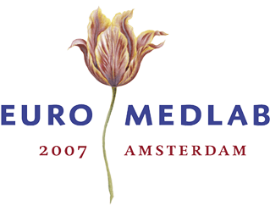Highlights of history: Clinical Chemistry before 1947
JJ Heeren, Breda and JPM Wielders, Amersfoort

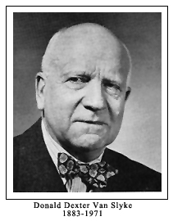
The examination of urine as a diagnostic tool is probably as old as medicine itself and certainly goes back to prehistoric times. Where Hippocrates (460-377 B.C.) is considered as Father of Medicine, through his Aphorisms he may be considered as well as Father of Clinical Chemistry. The Greek Hippocrates and his Roman equal Galenus (129-199) dominated the medical world – sometimes corrected by Arab physicians like Avicenna (980-1037) and Averroës (1126-1198) for many centuries – but were eventually defeated during and after the Renaissance in the 13th and 14th century.
Scientist like Paracelsus (1493-1541), Van Helmont (1577-1644), Sylvius (1614-1672) and Boerhaave (1668-1738) but also many others took over and changed theory and practice of medicine and early clinical chemistry.

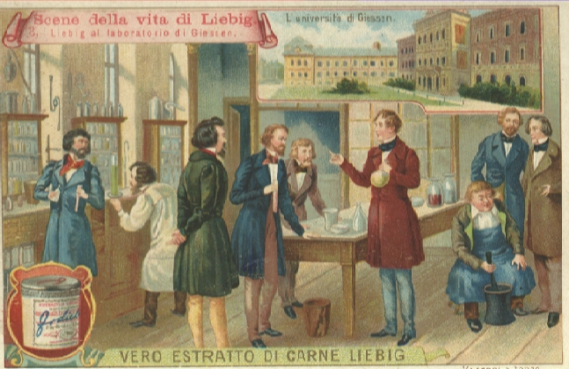
Yet, modern clinical chemistry started only after the fading away of alchemy and the development of a young and quantitative chemistry in the course of the 18th and 19th century. A landmark in that development and also in the history of clinical chemistry was Justus Liebig and his institute at the University of Giessen

Fig 1 Justus von Liebig (1803-1873), teaching at the university of Giessen.

Liebig, the author of ‘Die organische Chemie in ihrer Anwendung auf Physiologie und Pathologie’ (1842), educated many students from all over the world. The names of quite a number of them still have a familiar ring: Bence Jones (1813-1873), Heller (1813-1871), Fehling (1812-1885). As did Boerhaave’s students in the early 18th century, the chemists and physicians educated by Liebig spread over Europe and also over the new World, introducing the use of chemical methods in medical diagnosis in their home countries.
At first mostly qualitative methods were used but in the beginning of the 20th century also quantitative determinations were introduced. The older methods were mainly used for urine analysis but since then also for blood. A new jump was made when next to volumetric and gravimetric methods, colorimetric methods were introduced. In this respect the name of Swedish-born but America-educated Otto Folin (1867-1934) has to be remembered. In 1919 Folin and his co-worker Hsien Wu (1893-1959) published their ‘A System of Blood Analysis’, an early landmark in clinical chemistry..

Fig 2 Otto Folin in his lab at McLean Hospital (ca 1905)

Especially Germany had dominated in the development of (pre) clinical chemistry methods in the 2nd half of the 19th century. Now it was the United States starting with Folin that took over that position in the 1st half of the 20th century. As a true successor of Folin we can regard Donald D. van Slyke (1883-1971). In 1932 Van Slyke and his co-author and internist John P. Peters, published the two volumes of their ‘Quantitative Clinical Chemistry’ It was this book that put clinical chemistry definitely on the map of medical science all over the world.
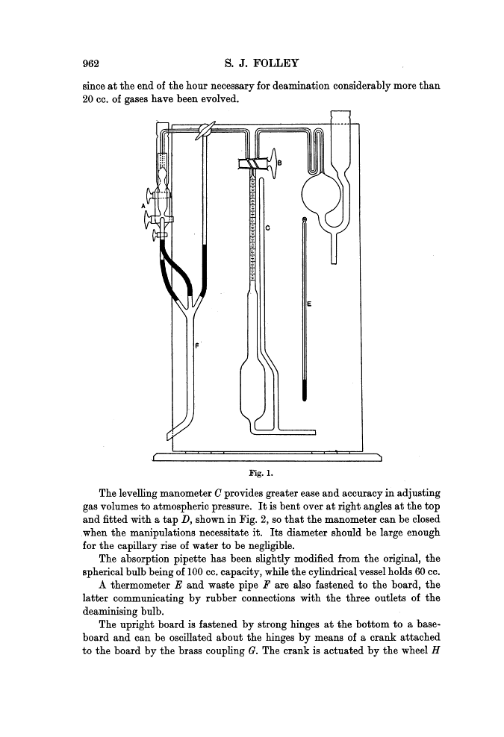

Fig 3 Donald D Van Slyke and an (improved) Van Slyke apparatus for determination of amino nitrogen
Yet, Peters & Van Slyke’s book wasn’t the first handbook of its kind. Its success was maybe even the temporary tail piece of a flood of textbooks in clinical chemistry in Europe as well as in America, started at the end of the 19th century. In 1886 O. Seifert & F. Müller published their ‘Taschenbuch der medizinisch-klinischen Diagnostik’ (reaching its 46th edition in 1940) and a few years later appeared ‘Praktikum der klinisch chemischen, mikroskopischen und bakteriologischen Untersuchungsmethoden’ by M. Klopstock & A. Kowarski. In America J.C. Todd & A.H. Sanford published in 1908 the first edition of their ‘Clinical Diagnosis by Laboratory Methods’, since its 14th edition in 1969 edited by I. Davidsohn & J.B. Henry. So, when Peters & Van Slyke published their textbook in 1932, the new discipline was already more or less mature.

Fig 4: Title pages of some ancient well known textbooks Peters-Van Slyk (1932) and Klopstock-Kowarski (1935)

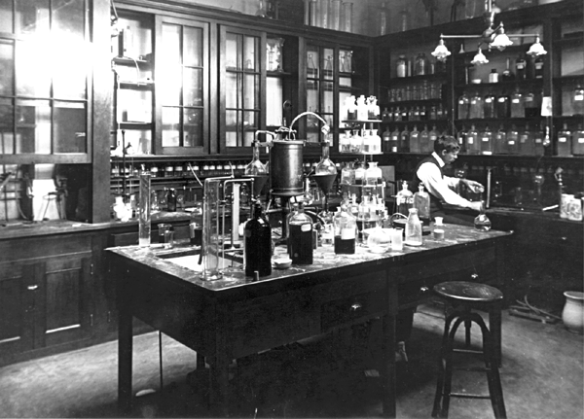
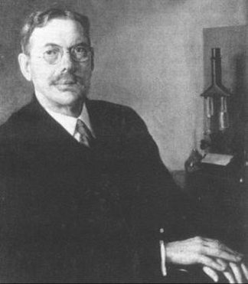
In the thirties and forties of the 20th century a number of new analytical techniques were introduced in clinical chemistry. Protein electrophoresis was developed by Arne Tiselius (1902-1971), the flame photometer for sodium and potassium by another Swedish scientist, Henrik Lundegardh (1888-1969) a plant physiologist.

World War II prevented the dispersion of the new techniques but immediately after the war a new blooming period sprouted for clinical chemistry. By then chromatography – Tswett, Lederer – came into use, at first mainly as thin layer chromatography. Around 1950 the fundaments of nuclear medicine and the base for radioimmunoassays were laid: the first radiopharmaceuticals became available and Schilling set up his test for vitamin B12 absorption. A few years later Berson and Yalow invented the first radioimmunoassay. It was indeed a fundamental change that clinical chemistry underwent in those years, years in which the Netherlands Society of Clinical Chemistry was founded.

