 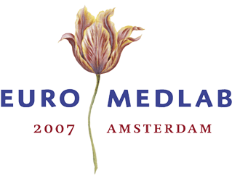Highlights of history: from uroscopy to urinalysis
JJ Heeren, Breda and JPM Wielders, Amersfoort

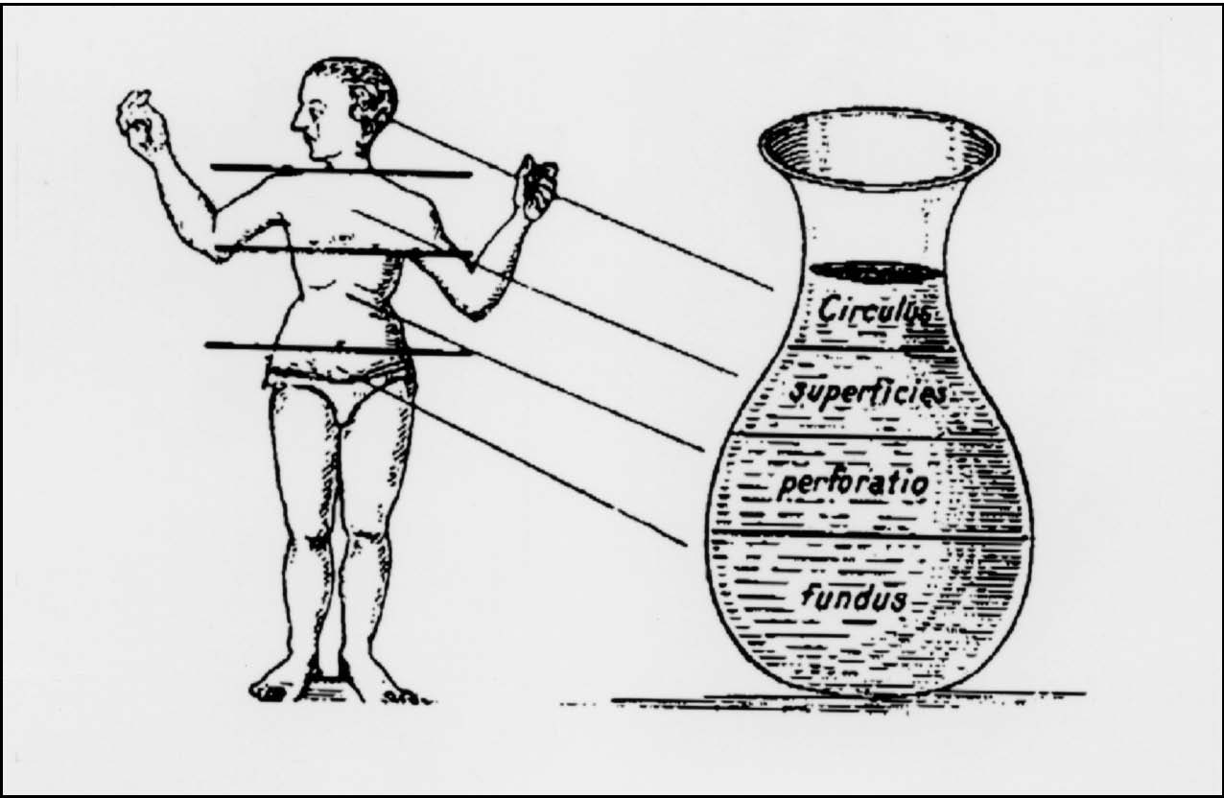
Which science was first: medicine or clinical chemistry? We will never know but for sure that the roots of both lie in prehistoric times. Hippocrates, in the 5th century B.C., considered to be the Father of Medicine may through his ‘Aphorisms’ be seen as Father of Clinical Chemistry as well. The well known ‘Ars longa, vita brevis’ is the first of that collection of Hippocrates’ aphorisms. Old medical papyri mentioned already that excessive urine production had to be regarded as a sign of illness. Up till about the 17th century the viewing of urine in a so-called matula, was the first, if not the only, diagnostic tool. Urine would carry information from the bodies health, just like a river carries soil and small stones from the regions passed. A book written by Theophilus (7th century ) was the standard for centuries.
Fig 1 Main parts of the body were thought to
correspond with certain parts of the matula

Uromancy (the guessing of the nature of the disease by viewing the patients urine) was a very serious part of medical diagnosis and sometimes the only source of information since in the middle ages the church had forbidden to touch certain parts of the body or seeing women unclothed. Doctor’s used a chart often in the form of a wheel showing urine colours, clarity, odour, foam and sediments as guideline to the diagnosis (fig 2). Dark urine was considered related to acute illness and (large amounts of) of light urine pointed at chronic disease.
Fig 2 Uroscopy “wheel” from The Fasciculus
Medicinae by Johannes De Ketham, 1491.

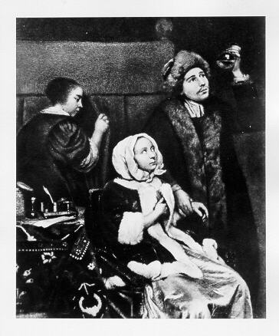
Nowadays we look at uroscopy as a rather unreliable or even shady tool reconsidering the writings of mediaeval authors as Paracelsus and Van Helmont and from the pictures of painters of the 17th century.

Fig 3 K. Netscher 1664 “Le médicin chez la malade”
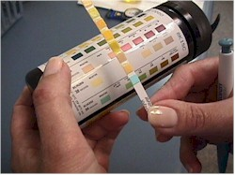
With the fading away of alchemy and the introduction of more scientific approach of iatrochemistry in medicine – by the Leyden professor Francois de le Boë Sylvius (1614-1672) - the first chemical methods came into use to detect the presence of constituents of urine that might be of diagnostic value. It was Sylvius’ student, Frederik Dekkers (1648-1720) who demonstrated the presence of protein in urine and described for the first time the phenomenon of albuminuria. Yet his findings fell into oblivion and were only rediscovered about 1765 by the Italian physician Domenico Cotugno.

The Frenchmen Rayer and Vigla introduced microscopy to examine the urine deposit in 1837 and the first photographs of cells in urine were taken in 1845. German doctors described casts. It was the book “Urine Deposits: their pathology and therapeutical indication” of Golding Bird (1844) that caused the final breakthrough of microscopy of the urinary sediment allowing to distinguish the organized and the non-organized components.

In the 19th century medicine and chemistry would change fundamentally by the introduction of new analytical methods. Chemical analysis obtained a permanent place in the testing of urine. They were mainly qualitative tests at those days and in the course of time literally hundreds of them were described in the medical journals and used by physicians in their praxis. Most of them are by now completely forgotten but some names have even now a familiar sound: Bang, Bence Jones, Fehling, Heller, Esbach, Tollens.

Fig 4 Golding Bird and some urine sediment preparations (around 1844)

Some of these qualitative tests – after the introduction of analytical chemical methods like volumetry, gravimetry and later also colorimetry – were ‘reconstructed’ into a quantitative variant as happened for example with the determination of sugar in urine according to Fehling and Benedict. In fact some of these 19th century methods experienced even a second revival with the introduction of dry chemistry methods in the second half of the 20th century!
Together with the development of analytical chemistry as well as physiological chemistry the number of metabolites in urine that could be measured quantitatively grew fast: chloride (according to Votocek or Volhardt), phosphates (Briggs), nitrogen (Kjeldahl, Folin), uric acid (Folin), urea (Conway, Folin, Marshall), creatinin (Folin), protein (Scherer) and so on. Increasing knowledge of enzymes and their significance, led to the measurement of diastase in urine according to Wohlgemuth.
The density of urine was measured by the picnometer or for routine work by the aerometer. The polarimeter served to determine the sugar. content of urine.

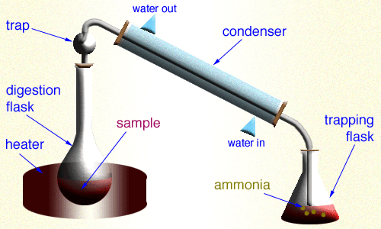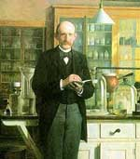

Picture 3: Determination of nitrogen-content according to Johan Kjeldahl

Chemical urinalysis before World War II was still very modest. That changed significantly after the war by the introduction of new analytical techniques like electrophoresis and flame photometry, originally introduced around 1935 by respectively Tiselius and Lundegarth.
A major contribution to urinalysis was the introduction of “dry chemistry” methods in the fifties. Based on the classical method of Fehling/Benedict, the American firm Ames developed a tablet-test that under the name Clinitest was launched on the market. That test for reducing sugars was soon thereafter followed by other urine tests. The introduction of the dipstick tests (Clinistix) to be read by comparison with a colour scale, made a semi-quantitative approach possible. Combining testpads on one strip in the eighties for e.g. leucocytes, erythrocytes and protein made it possible to use it as a screen to sieve out those samples that needed microscopy. In the course of time also the visual, human read out was replaced by reflectometry analysers. As in other areas of clinical chemistry also in the field of urinalysis automated analysis replaces the old craftsmanship of urine viewing. As an example of the latest generation of urine analysers we mention the iQ200 Automated Urine Microscopy Analyzer of Iris Diagnostics Division, which can be regarded as the third generation of uroscopy.

Finally a few words about another aspect of urinalysis. In Egyptian history urine was used in very primitive pregnancy testing, by comparing the sprouting time of grain wetted with the women’s urine with that of a priest.
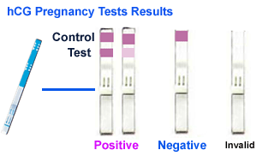
The history of pregnancy determination with urine had and has a very close relationship with endocrinology and with the history of that discipline. For centuries the use of seeds or animals – frogs! - was necessary to determine pregnancy. With the development of endocrinology and the introduction of hCG tests to determine gravity, new methods became available both inside the lab as well as for home testing. In some aspects urine remains the river that collects all kind of information from the body, as our ancestors believed.

